HEALTH CARE PROVIDER

Smart health assistance in your pocket”

🏥 1. Clean & Trust-Building Hero Section

What it includes:
- App logo (top left)
- Navigation: Home | Find Doctor | Appointments | Services | Contact
- Main headline:
“Your Health, Our Priority.”
- Subtext:
Book appointments, consult doctors online, and access your medical records — all in one place.
- CTA buttons:
  - 🟢 Book Appointment
  - 🔵 Talk to a Doctor
- Background: soft blue/white gradient or doctor-patient image
Why?
Blue and white tones build trust and calmness.

🔍 2. Quick Access Section (User-Focused)

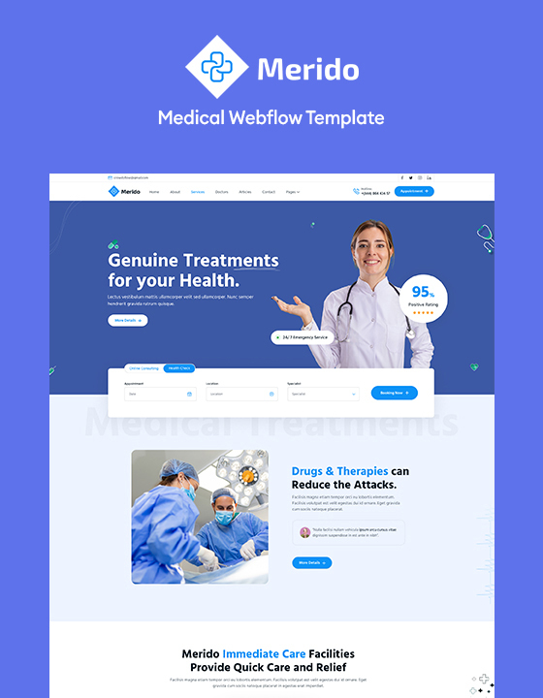
4

What it includes:
- App logo (top left)
- Navigation: Home | Find Doctor | Appointments | Services | Contact
- Main headline:
“Your Health, Our Priority.”
- Subtext:
Book appointments, consult doctors online, and access your medical records — all in one place.
- CTA buttons:
  - 🟢 Book Appointment
  - 🔵 Talk to a Doctor
- Background: soft blue/white gradient or doctor-patient image
Why?
Blue and white tones build trust and calmness.

🔍 2. Quick Access Section (User-Focused)


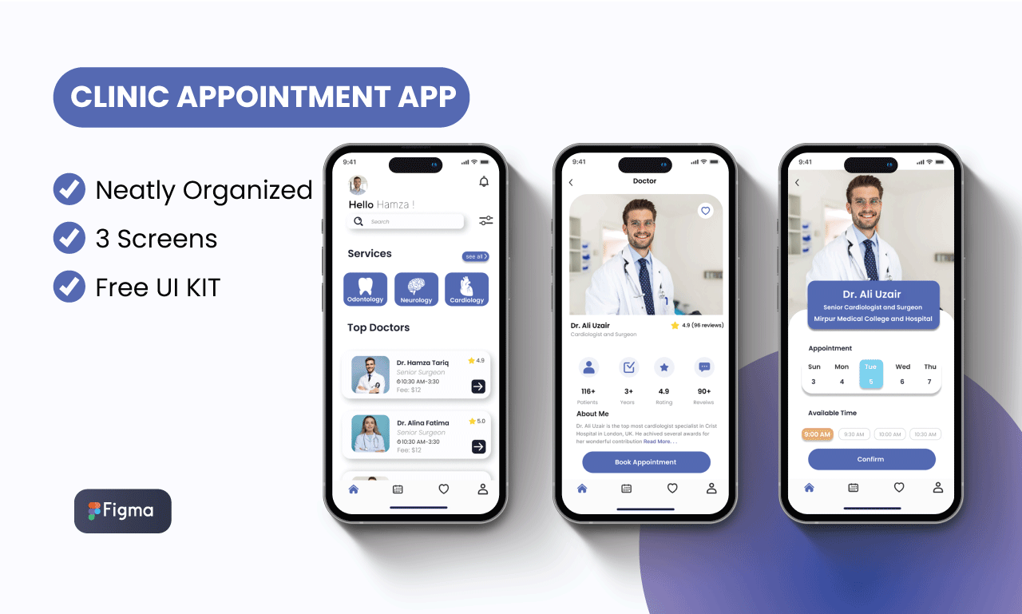
4
Include 4–6 large icons:
- 👨‍⚕️ Find a Doctor
- 📅 Book Appointment
- 💊 Order Medicines
- 🧪 Lab Tests
- 📄 Medical Records
- 🚑 Emergency Help
Make them clickable cards with simple icons.

⭐ 3. Featured Doctors / Services
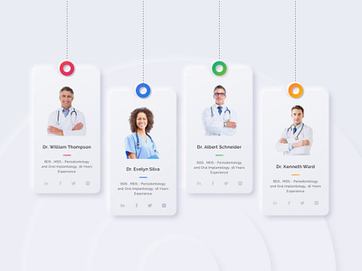

4
Each doctor card should show:
- Doctor photo
- Name & specialization
- Experience (e.g., 12+ years)
- Ratings ⭐⭐⭐⭐⭐
- “Book Now” button
This builds credibility immediately.

📱 4. Why Choose Us Section
Short bullet points:
- 24/7 Online Consultation
- Certified Specialists
- Secure Medical Records
- Easy Appointment Booking
- Insurance Support
Add trust badges:
- HIPAA compliant (if applicable)
- Certified healthcare provider logos

💬 5. Testimonials / Reviews
Patient reviews with:
- Photo
- Name
- Short quote
- Star rating
Social proof increases conversion.

📍 6. Footer Section
Include:
- Contact information
- Clinic locations map
- Emergency hotline number
- Social media links
- Privacy policy & terms

🎨 Design Style Recommendation
Element | Suggested Style
Colors | Light blue, white, soft green
Font | Clean sans-serif (e.g., Inter, Roboto)
Layout | Spacious, minimal, mobile-first
Tone | Professional but friendly

🔐 Important Front-Page Priorities
- Clear emergency contact button (always visible)
- Easy login / sign-up
- Fast loading
- Accessibility (large text, readable contrast)
- Secure & compliant messaging

If you'd like, I can:
- Create a wireframe layout structure
- Design a React front page sample
- Provide a mobile app front screen design
- Suggest a branding theme (colors, typography, logo idea)
What type of health provider app are you building? (Hospital, clinic, telemedicine, pharmacy, lab services?)
I prefer this response
ChatGPT
Response 2
Here’s what a modern, user-friendly front page (landing screen) of a Health Provider Application typically looks like, depending on whether it’s for patients, doctors, or both.

🏥 1. Clean & Trustworthy Header Section
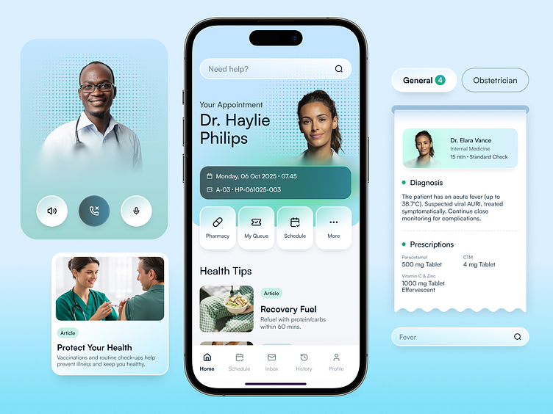

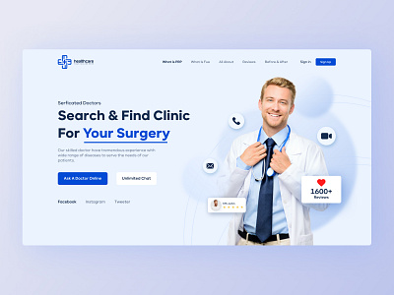
4

🔹 Top Navigation Bar
- Logo (clinic/hospital name)
- Home
- Services
- Doctors
- Appointments
- About Us
- Contact
- Login / Sign Up (highlighted button)

🔹 Hero Section (Top Banner)
- Warm healthcare-related image (doctor + patient, telehealth, etc.)
- Short headline like:
“Your Health, Our Priority”
- Subtext:
Book appointments, consult doctors, and access records — anytime, anywhere.
- Call-to-action buttons:
  - Book Appointment
  - Find a Doctor
  - Emergency Help

👨‍⚕️ 2. Key Features Section

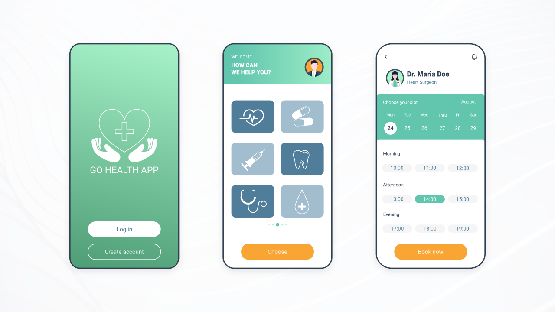
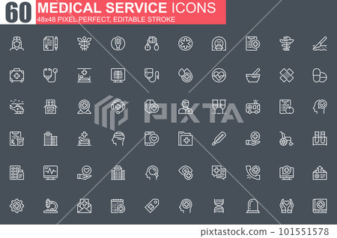
4
Displayed as icon cards or tiles:
- 🩺 Online Consultation
- 📅 Appointment Booking
- 🧾 Medical Records Access
- 💊 E-Prescriptions
- 🔔 Reminders & Notifications
- 🧪 Lab Reports
Each card includes:
- Small icon
- Short description
- “Learn More” link

👩‍⚕️ 3. Doctor or Specialist Section

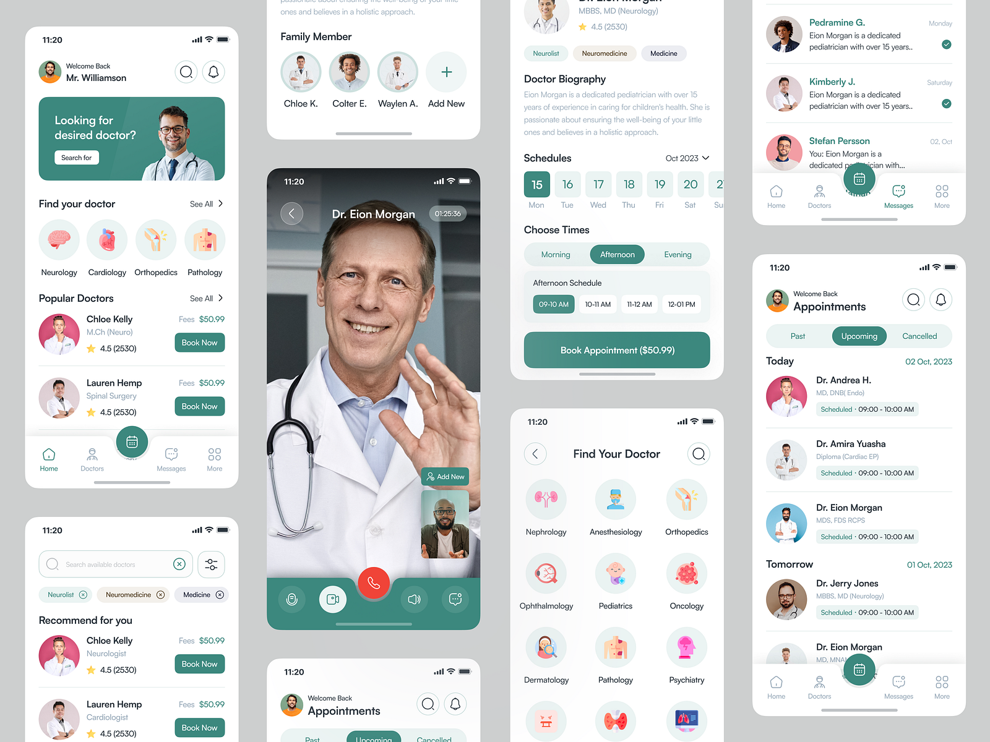
4
Shows:
- Doctor photo
- Name
- Specialization
- Years of experience
- Rating
- “Book Now” button
You can also include filters:
- By specialty
- By availability
- By location

📊 4. Why Choose Us / Trust Section
- Patient testimonials
- Number of doctors
- Years of experience
- Certifications
- Insurance partners
Example stats:
- 50+ Specialists
- 10,000+ Happy Patients
- 24/7 Support

📱 5. App Download Section (If Mobile App)

4
- Screenshot of the mobile app
- Google Play & App Store buttons
- QR code download option

📍 6. Footer Section
- Contact information
- Address & map
- Social media links
- Privacy policy
- Terms & Conditions
- Emergency contact number (highlighted in red)

💡 Bonus: Modern UI Style Suggestions
- Soft colors: Blue, teal, white (trust & calm feeling)
- Rounded cards
- Clean typography
- Minimal clutter
- Accessibility-friendly fonts
- Fast loading & mobile responsive

If you'd like, I can:
- Design a wireframe layout
- Create a sample UI structure
- Suggest React / HTML front-page code
- Or tailor it specifically for a clinic, hospital, telemedicine, or lab system
What type of health provider app are you building?
I prefer this response

Python code used
import tkinter as tk
from tkinter import messagebox

# In-memory storage
patients = []
appointments = []

# Function to register patient
def register_patient():
name = name_entry.get()
age = age_entry.get()
gender = gender_entry.get()

if name == "" or age == "" or gender == "":
messagebox.showerror("Error", "All fields are required!")
return

patients.append({"name": name, "age": age, "gender": gender})
messagebox.showinfo("Success", "Patient Registered Successfully!")
clear_patient_fields()

# Function to book appointment
def book_appointment():
patient_name = appt_name_entry.get()
date = appt_date_entry.get()
doctor = appt_doctor_entry.get()

if patient_name == "" or date == "" or doctor == "":
messagebox.showerror("Error", "All fields are required!")
return

appointments.append({
"patient": patient_name,
"date": date,
"doctor": doctor
})

messagebox.showinfo("Success", "Appointment Booked Successfully!")
clear_appointment_fields()

# Function to view patients
def view_patients():
output = ""
for p in patients:
output += f"Name: {p['name']}, Age: {p['age']}, Gender: {p['gender']}\n"

if output == "":
output = "No patients registered."

messagebox.showinfo("Patient List", output)

# Clear fields
def clear_patient_fields():
name_entry.delete(0, tk.END)
age_entry.delete(0, tk.END)
gender_entry.delete(0, tk.END)

def clear_appointment_fields():
appt_name_entry.delete(0, tk.END)
appt_date_entry.delete(0, tk.END)
appt_doctor_entry.delete(0, tk.END)

# Main Window
root = tk.Tk()
root.title("Health Care Provider Application")
root.geometry("500x500")

# Patient Registration Section
tk.Label(root, text="Patient Registration", font=("Arial", 14, "bold")).pack(pady=10)

tk.Label(root, text="Name").pack()
name_entry = tk.Entry(root)
name_entry.pack()

tk.Label(root, text="Age").pack()
age_entry = tk.Entry(root)
age_entry.pack()

tk.Label(root, text="Gender").pack()
gender_entry = tk.Entry(root)
gender_entry.pack()

tk.Button(root, text="Register Patient", command=register_patient).pack(pady=10)

# Appointment Section
tk.Label(root, text="Book Appointment", font=("Arial", 14, "bold")).pack(pady=10)

tk.Label(root, text="Patient Name").pack()
appt_name_entry = tk.Entry(root)
appt_name_entry.pack()

tk.Label(root, text="Date").pack()
appt_date_entry = tk.Entry(root)
appt_date_entry.pack()

tk.Label(root, text="Doctor Name").pack()
appt_doctor_entry = tk.Entry(root)
appt_doctor_entry.pack()

tk.Button(root, text="Book Appointment", command=book_appointment).pack(pady=10)_

